**Results**

The main focus of this research was to determine how male and female professional athletes present themselves to their audience via Twitter.

The findings reflect the cluster analysis of each gender's Twitter presence, as well as how presentational strategy variables correlate with gender.

**Twitter Activity**

Anyone who is interested is able to follow professional athletes on Twitter. At present, there is no trustworthy method to determine the demographics of followers. At the time of analysis, the mean number of individuals following the sample of male athletes on Twitter was 22.79million (SD = 18.72). Two extreme cases were detected in Cristiano Ronaldo and LeBron James. These athletes among the most followed people on Twitter. Cristiano Ronaldo had accumulated 69.3 million followers at the time of study and was the 8th most followed person on Twitter, whilst LeBron James had accumulated 40.6 million followers and was the 24th most followed person. They were thus identified as outliers that skewed the collective data (Barnett & Lewis, 1984). With the outliers removed from calculations, the average number of followers of men decreased to 13.41 (SD = 4.99). By contrast, the sample of female athletes had a mean of 4.22 million followers (SD = 3.36), with no influential cases detected.

The athletes in the sample employed their Twitter accounts not only to be followed but also to follow other Twitter accounts. The mean number of Twitter accounts followed by female athletes was 227 (SD = 115), and they posted a mean of 398 tweets per athlete (SD - 29.7) during the period under review.

By contrast, male athletes followed a mean of 469 accounts (SD = 424). An outlier was again detected in Kevin Durant, who followed 1,453 accounts. With this outlier removed, the mean became 359 followed accounts (SD - 261). Male athletes posted a mean of 394 tweets per athlete (SD = 40.5) during the time of study.

It is recognized that the number of followers a person accumulates is not necessarily indicative of the influence or reach of a Twitter account (Leonhardt, 2011). The analytical tool Klout was therefore used to calculate each athlete's impact score. As opposed to measuring influence based solely on the number of followers a Twitter user is able to collect, an impact score takes into account factors such as the number of times a Twitter name is mentioned by others and the frequency with which a person is actually communicating (Leonhardt, 2011). The mean impact score of female athletes was 80.25 (5D = 7.7), with the highest impact calculated for Serena Williams with a score of 90.2. The mean impact score for male athletes was 87.6 (SD = 3.5), with the highest impact achieved by LeBron James with a score of 92.4.

The data illustrate that the largest percentage of tweets were direct messages. For male athletes this accounted for 3367 tweets or 85.56% and for female athletes there were 3167 direct tweets or 79.51%. A large number of tweets contained a link, in fact 2996 (76.13%) of male athletes tweets contained links and 3110 (78.08%) of female athletes tweets contained a link to a picture, website or another social media site. Retweets made up 17.48% of the total tweets collected.

**Athlete Self-Presentation**

**Clusters:**

The clusters for female athletes were:

|  |  |
| --- | --- |
| Cluster 1: feeling happy | Love, thank, happy, great, good, today |
| Cluster 2: Interview / photo-shoot | Cover, month, excited, pics, story, interview |
| Cluster 3: Birthday | birthday, love, year, wishing, hope, friends |
| Cluster4: Celebration | Baby, santa, dearest, happy, love, hugs |
| Cluster 5: Game day | Wait, play, league, love, tonight, favourite |

Cluster 1, 'feeling happy', captured comments like Ana Ivanovic's, 'Love walking up here every day so beautiful', as well as Sania Mirza's tweet, 'Me and all my friends having a great time ', Alex Morgan was delighted to be back living in Orlando and tweeted' I'm so in love with Orlando and so happy to be back living here. Today, and every day, we are #OrlandoUnited'.

Cluster 2, found words that related to photo shoots and interviews. This cluster came from tweets like this form Maria Sharapova, 'Grazia Russia cover and interview with @Porsche'. Another tweet from Ana Ivanovic said, ' Thank you for the cover story. It was great talking to you guys' and Caroline Wozniacki was sharing her inclusion in Sports Illustrated photo shoot with the tweet, ' The new @si_swimsuit is on the stands today!!! So excited and honored to be included in the issue for the third straight year! '.

Cluster 3: contained words in connection to birthdays. Maria Sharapova retweeted a tweet wishing her a happy birthday, 'Wishing this sweet as Sugarpova tennis star, a very happy birthday! Jessica Ennis tweeted in response to a post from Shelly Rudman about her daughter turning 6, '@ShelleyRudman wow can't believe that! Happy Birthday Ella'

Cluster 4, collected words that concerned the topic of celebration, Caroline Wozniacki posted, 'When one of your dearest and oldest friends gets married it's time to celebrate'. Sydney Leroux posted a picture of her baby in a Santa costume and tweeted 'My Santa baby' and Maria Sharapova celebrated the launch of her book with the tweet, ' This was incredible! The line along the NY streets!! The amount of love, hugs, kind words. THANK YOU'.

Cluster 5 was about a game that was being played soon. Comments leading to this cluster were, 'Landed in Manchester 24 hours until Champions League Semi Final! #uwcl ' from Alex Morgan. Venus Williams who was going to play for the Washington Kastles (a franchise competing in the World Team Tennis) tweeted, 'Can't wait to play for @WashKastles tonight in Philly' and Maria Sharapova commented that she was 'So thrilled to be playing at one of the biggest indoor arenas I've ever played at today in San Juan'.

The clusters for male athletes were:

|  |  |
| --- | --- |
| Cluster 1: Team | Good, great, happy, congrats, game, team |
| Cluster 2: Hard work | Work, hard, dedication, top, gym, guys |
| Cluster 3: Interview / photo-shoot / video | Story, full, cover, Instagram, dream, success |
| Cluster 4: friends / family support | Thank, wishes, support, kind, best, words |
| Cluster 5: Game Day | Ready, game, tonight, evening, tomorrow,  strong |

Cluster 1 was words related to the team, this resulted from comments like, 'Congrats to the team for bringing home that State Championship', from Carmelo Anthony. Kevin Durant commented on the Washington Redskins win by tweeting, 'Good win Skins, Cowboys pass the sticks', and Wayne Rooney said, 'Good win today and a solid performance from the team Time to get ready for Thursday'.

Cluster 2 contained words relating to hard work. These words came from Tweets like, 'Love it deserve it. Rio Ferdinand tweeted, ' @Chrisgunter16 @ReadingFC Love it... deserve it! Role model to the next gen... hard work and dedication!! whilst Cristiano Ronaldo encouraged fans to,'Maximize your time in the gym. Work smart, focus on your goals and prepare for any challenge that comes your way #TrueToYourStory #sponsored'.

Cluster 3 was about interviews, videos and photo-shoots. Rio Ferdinand advertised his charity foundation with the tweet, 'Filming at the @riofoundation great work the team are doing.. follow my Instagram story to see behind the scenes!'. Kevin Durant linked to a video of his play with the tweet, I let my play do the talking. #BEHEARD Watch the full @BeatsByDre vid here: https://t.co/05zA4hgRhd https://t.co/Xlq2L6PncE'.

Cluster 4 related to support received from friends and family. Sachin Tendulkar tweeted this comment when he saw a picture of one of his fans who was delighted to receive a souvenir from him 'Now this really brought a big smile on my face I am very grateful for all the love and support'. Kobe Bryant tweeted, ' Thank you all for the birthday shouts and wishes! 40 is right around the corner #virgo #timehaswings'

Cluster 5 is about a game just played or one coming up soon. Sachin Tendulkar said that is was a 'Tough game today well fought out'. Stephen Curry posted the comment, 'S/O to #DubNation showing up strong for the preseason game tonight! Crazy atmosphere. Always Good to see my guy @Mospeights16 on the court!'.

**Word-Cloud**

From the word cloud analysis the following two images were created:

Female athletes:

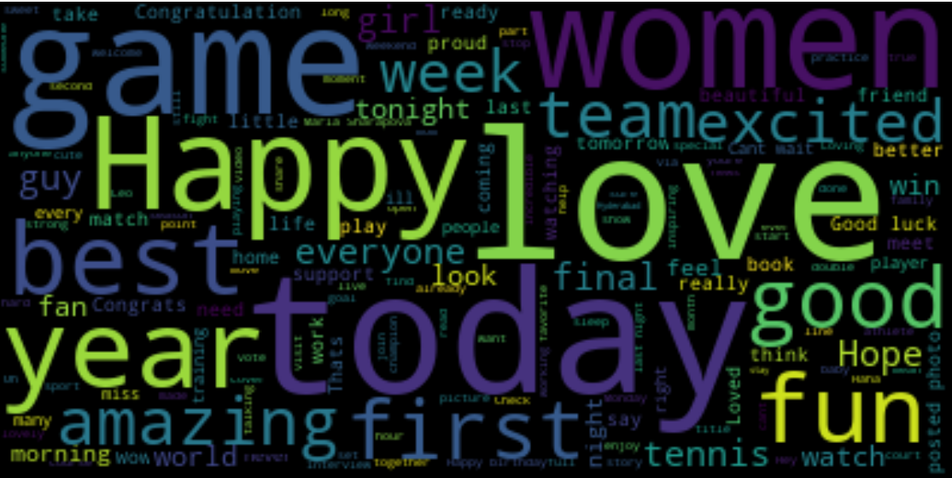

Male athletes:

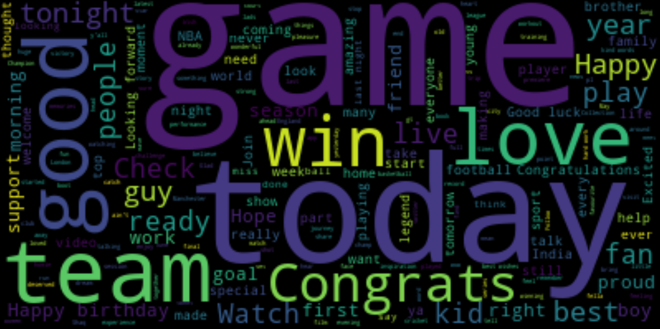

The word count resulting from the word Cloud analysis is:

|  |  |  |  |  |
| --- | --- | --- | --- | --- |
|  | Female* | Male | Difference | Percentage difference |
| Team | 63 (50) | 156 () | -93 | -42.46575342 |
| Player | 30 (26) | 42 () | -12 | -16.66666667 |
| Game | 112 (118) | 164 () | -52 | -18.84057971 |
| Women | 109 (51) | 17 () | 92 | 73.01587302 |
| Men | 13 (11) | 9 () | 4 | 18.18181818 |
| Family | 35 (28) | 64 () | -29 | -54.69 |
| love | 165 (144) | 113 () | 52 | 18.70503597 |
| Happy | 126 (106) | 149 () | -23 | -8.363636364 |
| Best | 70 (66) | 111 () | -41 | -22.6519337 |
| Year | 82 (55) | 94 () | -12 | -6.818181818 |
| good | 120 (110) | 193 () | -73 | -23.32268371 |
| First | 65 (60) | 57 () | 8 | 6.557377049 |
| Today | 129(121) | 131 () | -115 | -78.23129252 |
| Win | 52 (52) | 106 () | -54 | -34.17721519 |
| congrats | 89 (77) | 156 () | -67 | -27.34693878 |

Women includes: women, woman and female.

Men includes: men, man and male.

Year includes: year, years

Congrats includes: congrats, congratulations, congratulate.

* Upon further analysis of the data it was found that Sania Mirza was an outlier in relation to referencing 'women'. She had accounted for 58 of the 109 references to 'women' in her tweets. This is probably due to the fact that she is a 'UN Women's Goodwill Ambassador'. As she was affecting the word count she was replaced with the next highest female athlete on the list, Hope Solo, an America soccer player. When her tweets were put in to the word count the resultant numbers are in bracket in the above table.

For the men Rio Ferdinand is the outlier when it comes to referencing 'man'. He has a fondness for referring to people a 'my man' and he also played for Man United which he references.

When an independent samples t-test was done on these word counts no significant difference was found (significance of .171. A significance of < 0.05 would be a significant difference). It felt that the sample size was not a large enough to have high power of detecting a meaningful difference and was affecting the t-test scores so an extra 10 male and female athletes were analysed to see what the t-test scores were.